Nama : Dimas Shofa Gunarso

NIM : 18090061

Kelas : 5D

Laporan Praktikum 4

1. Source Code

Web.php 🡪 application/controllers/

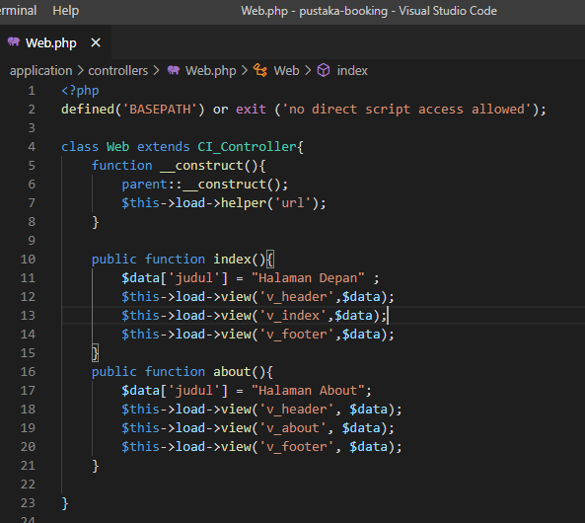

v_header.php 🡪 application/views/

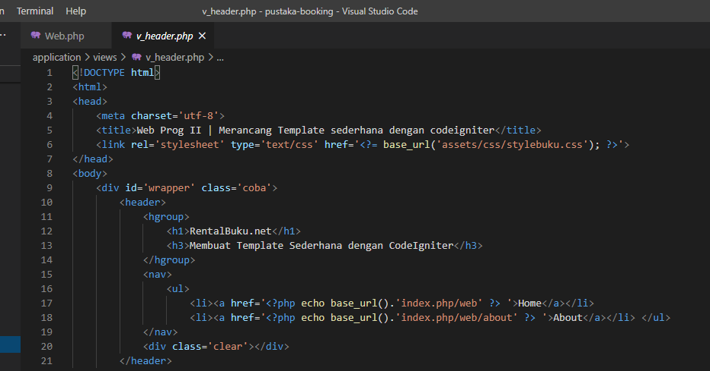

v_index.php 🡪 application/views/

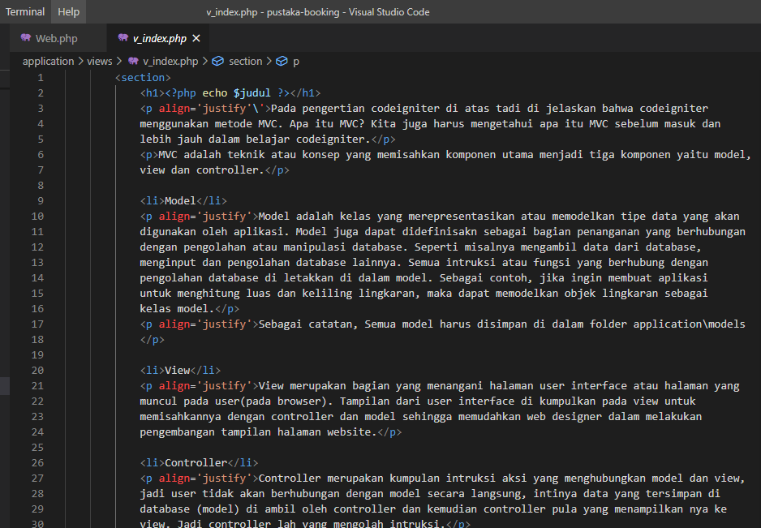

v_footer 🡪 application/views/

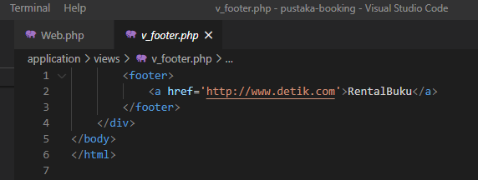

stylebuku.css 🡪 pustaka-booking/assets/css/

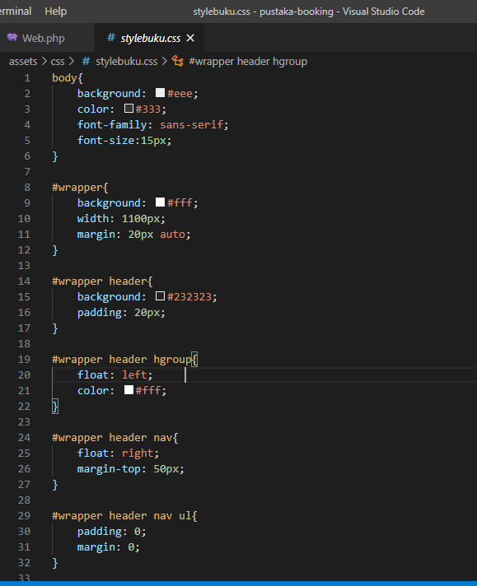

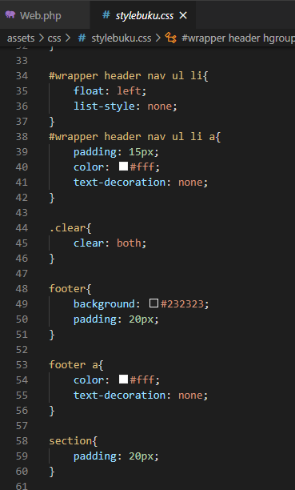

config.php 🡪 application/config/

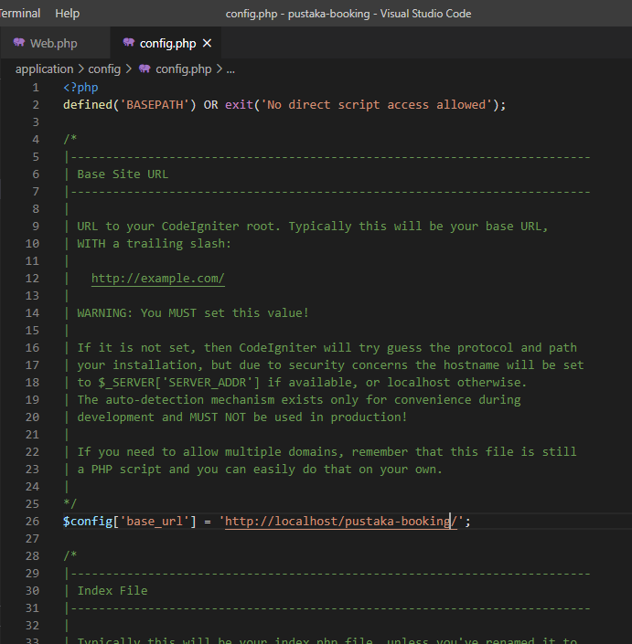

autoload.php 🡪 application/config/

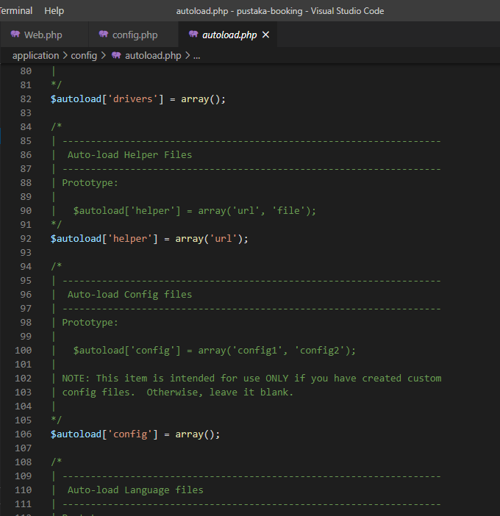

v_about.php 🡪 application/views/

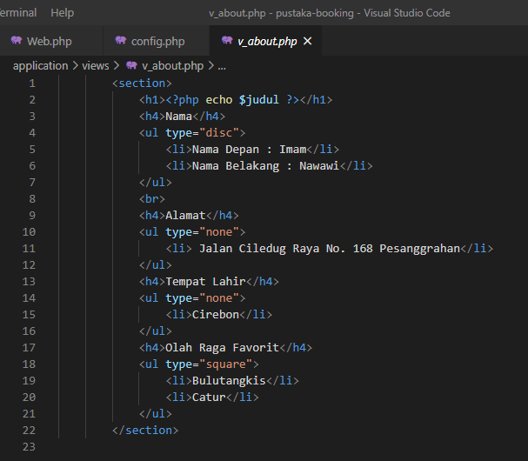

1. URL

<http://localhost/pustaka-booking/web>

<http://localhost/pustaka-booking/index.php/web/about>

1. Capture Output Program

